LAB EXPERIMENT RECORD
SET 15: PRODUCT SALES ANALYSIS
Department | AIDS
Course Code / Course Name | DSA0601 / Data Handling and Visualization
Experiment | Data Visualization using R
Name | B. Pallavi
Register Number | 192424243
Date | 08 October 2026
Day | Thrusday

Aim
To visualize monthly product sales data using a grouped bar chart, stacked area chart, and sales table, and to build an interactive dashboard using R.
Dataset: Monthly Product Sales
Product ID | Product Name | January Sales | February Sales | March Sales
1 | Product A | 2000 | 2200 | 2400
2 | Product B | 1500 | 1800 | 1600
3 | Product C | 1200 | 1400 | 1100

PROGRAM 1: Grouped Bar Chart of Product Sales
Create a grouped bar chart to visualize the sales of each product for the first quarter. Label the chart elements.
R Code
# Product Dataset
product <- c(
"Product A",
"Product B",
"Product C"
)
january <- c(2000, 1500, 1200)
february <- c(2200, 1800, 1400)
march <- c(2400, 1600, 1100)
# Sales Matrix
sales <- rbind(
January = january,
February = february,
March = march
)
# Grouped Bar Chart
barplot(
sales,
beside = TRUE,
names.arg = product,
xlab = "Product",
ylab = "Sales",
main = "First Quarter Product Sales",
col = c(
"skyblue",
"lightgreen",
"orange"
)
)
legend(
"topright",
legend = c(
"January",
"February",
"March"
),
fill = c(
"skyblue",
"lightgreen",
"orange"
)
)
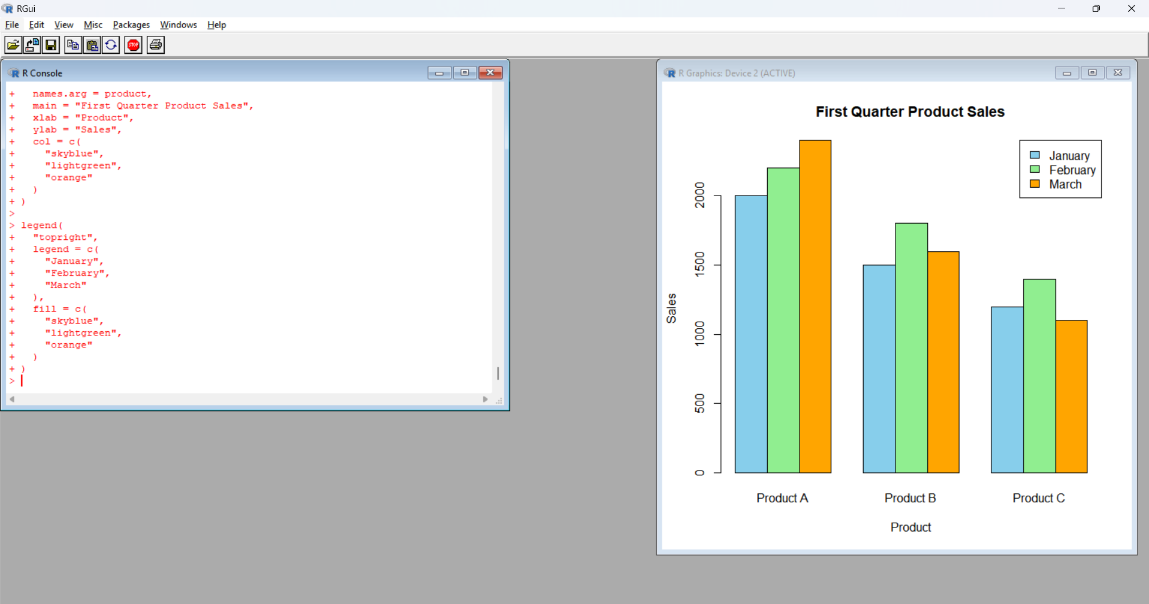
Output 1: First Quarter Product Sales
The grouped bar chart displays the January, February and March sales of Products A, B and C.
Observation
The grouped bar chart shows that:
- Product A has the highest sales in all three months.
- Product A sales increase from 2000 in January to 2400 in March.
- Product B has its highest sales of 1800 in February.
- Product C has the lowest sales of 1100 in March.
PROGRAM 2: Stacked Area Chart of Product Sales
Generate a stacked area chart to represent the overall sales trend for all products over the three months.
R Code
# Product Sales Data
months <- c(
"January",
"February",
"March"
)
product_A <- c(2000, 2200, 2400)
product_B <- c(1500, 1800, 1600)
product_C <- c(1200, 1400, 1100)
# Sales Matrix
sales <- rbind(
product_A,
product_B,
product_C
)
# Cumulative Sales
cumulative_sales <- apply(
sales,
2,
cumsum
)
# Create Plot
plot(
1:3,
cumulative_sales[3, ],
type = "n",
xaxt = "n",
xlab = "Month",
ylab = "Sales",
main = "Stacked Area Chart of Product Sales"
)
axis(
1,
at = 1:3,
labels = months
)
# Product A
polygon(
c(1:3, 3:1),
c(
cumulative_sales[1, ],
rev(rep(0, 3))
),
col = "skyblue"
)
# Product B
polygon(
c(1:3, 3:1),
c(
cumulative_sales[2, ],
rev(cumulative_sales[1, ])
),
col = "lightgreen"
)
# Product C
polygon(
c(1:3, 3:1),
c(
cumulative_sales[3, ],
rev(cumulative_sales[2, ])
),
col = "orange"
)
legend(
"topleft",
legend = c(
"Product A",
"Product B",
"Product C"
),
fill = c(
"skyblue",
"lightgreen",
"orange"
)
)
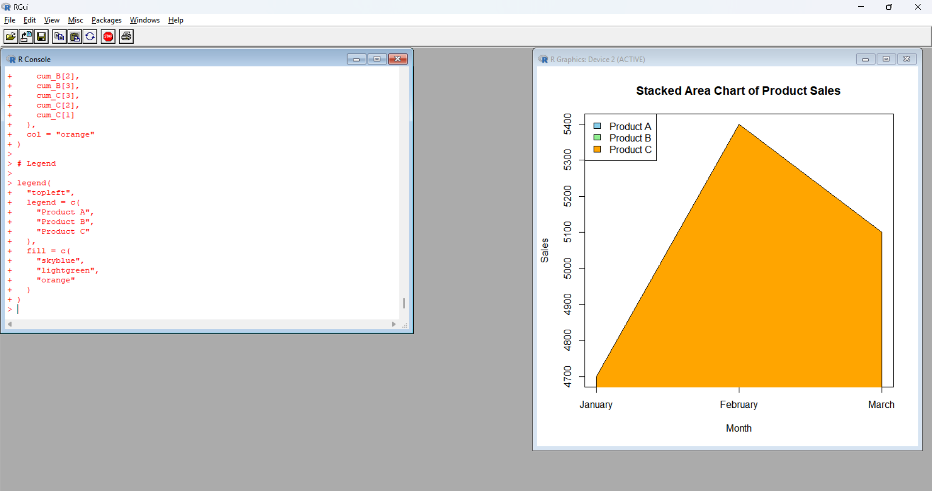
Output 2: Stacked Area Chart
The stacked area chart represents the contribution of Products A, B and C to the overall sales during January, February and March.
Observation
The stacked area chart shows that:
- Product A contributes the largest portion of sales.
- Total sales increase from January to February.
- Total sales decrease slightly in March.
- Product C sales decrease from February to March.
PROGRAM 3: Monthly Product Sales Table
Build a table to show the monthly sales data for each product. Label the table elements.
R Code
# Monthly Product Sales Data

sales_data <- data.frame(
Product_ID = c(1, 2, 3),
Product_Name = c(
"Product A",
"Product B",
"Product C"
),
January_Sales = c(
2000,
1500,
1200
),
February_Sales = c(
2200,
1800,
1400
),
March_Sales = c(
2400,
1600,
1100
)
)
# Display Table
print(sales_data)

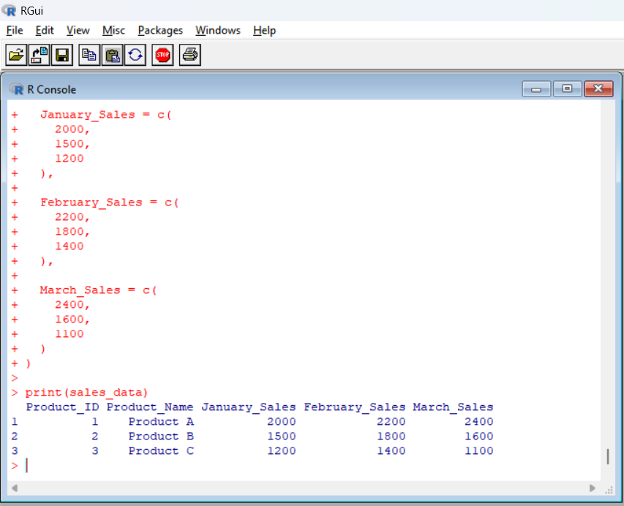
Output 3: Monthly Product Sales Table
Product_ID Product_Name January_Sales February_Sales March_Sales
1 1 Product A 2000 2200 2400
2 2 Product B 1500 1800 1600
3 3 Product C 1200 1400 1100
Observation
The table displays complete monthly sales information for Products A, B and C for the first quarter.

PROGRAM 4: Interactive Product Sales Dashboard
Develop an interactive dashboard combining the grouped bar chart, stacked area chart, and the table for interactive exploration of sales data.
R Code
library(shiny)
# Product Sales Data
sales_data <- data.frame(
Product_ID = c(1, 2, 3),
Product_Name = c(
"Product A",
"Product B",
"Product C"
),
January = c(2000, 1500, 1200),
February = c(2200, 1800, 1400),
March = c(2400, 1600, 1100)
)
# User Interface

ui <- fluidPage(
titlePanel(
"Product Sales Analysis Dashboard"
),
sidebarLayout(
sidebarPanel(
selectInput(
"product",
"Select Product:",
choices = c(
"All",
sales_data$Product_Name
)
)
),
mainPanel(
plotOutput("bar_chart"),
plotOutput("area_chart"),
tableOutput("sales_table")
)
)
}
# Server
server <- function(input, output) {
output$bar_chart <- renderPlot({
if(input$product == "All") {
sales <- rbind(
sales_data$January,
sales_data$February,
sales_data$March
)
barplot(
sales,
beside = TRUE,
names.arg = sales_data$Product_Name,
xlab = "Product",
ylab = "Sales",
main = "First Quarter Product Sales",
col = c(
"skyblue",
"lightgreen",
"orange"
)
}
legend(
"topright",
legend = c(
"January",
"February",
"March"
),
fill = c(
"skyblue",
"lightgreen",
"orange"
)
)
} else {
selected <- sales_data[
sales_data$Product_Name ==
input$product,
]
values <- c(
selected$January,
selected$February,
selected$March
}
barplot(
values,
names.arg = c(
"January",
"February",
"March"
),
xlab = "Month",
ylab = "Sales",
main = paste(
"Monthly Sales -",
input$product
)
)
}
})
output$area_chart <- renderPlot()
sales <- rbind(
sales_data$January,
sales_data$February,
sales_data$March
)
total_sales <- colSums(sales)
plot(
total_sales,
type = "o",
xaxt = "n",
xlab = "Month",
ylab = "Total Sales",
main = "Overall Sales Trend",
pch = 19
)
axis(
1,
at = 1:3,
labels = c(
"January",
"February",
"March"
)
)
})
output$sales_table <- renderTable(
if(input$product == "All") }
sales_data
} else {
sales_data[
sales_data$Product_Name ==
input$product,
]
}
})
}
# Run Dashboard
shinyApp(
ui = ui,
server = server
)
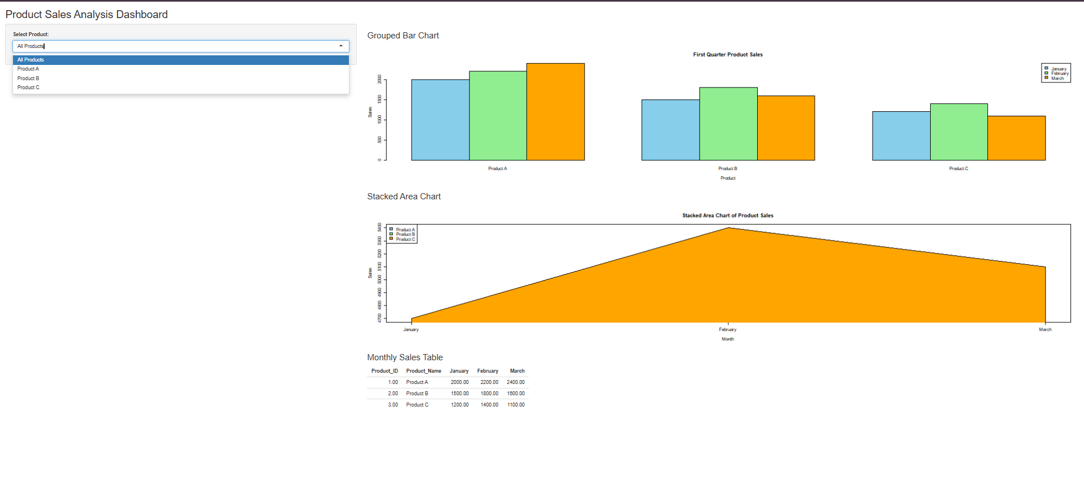
Output 4: Product Sales Analysis Dashboard
The dashboard combines the grouped bar chart, sales trend visualization and monthly sales table into a single interactive view.
Observation
The dashboard allows users to select a product and explore its monthly sales. It also provides the complete product sales table for comparison.
Procedure
- Create product names and monthly sales vectors in R.
- Use rbind() to create the sales matrix.
- Use barplot() with beside = TRUE to create the grouped bar chart.
- Create cumulative sales values for the products.
- Use polygon() to create the stacked area chart.
- Create a data frame to display the monthly product sales.
- Install and load the Shiny package.
- Create the dashboard user interface.
- Create the grouped bar chart in the dashboard.
- Create the sales trend visualization.
- Display the monthly product sales table.
- Run the Shiny application to create the interactive dashboard.
Result
The monthly product sales data was successfully visualized using a grouped bar chart, stacked area chart, and sales table. An interactive R Shiny dashboard was also created to display and explore the product sales data.

